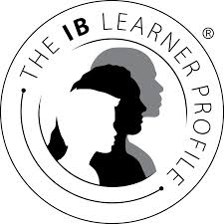
The IB Learner Profile
(Once completed place in your PPS binder under IB Learner Profile tab)

Trait: ___________________________________________ (Define below)

Learning experience: (Share your experience within the context of your school experience)

Personal connection: (Share your own experience with ___________________________________)

Reflection: (Make connections to the aims of the IB program)

Illustration: (Create an image on back that captures your understanding of open-minded)

