Sophocles’ Antigone
Stagebill Activity

STUDENT TASK: Create an informative and aesthetically pleasing stagebill.
After reading the tragic play of Antigone by Sophocles you will create a stagebill that will include the following components:
- Cover page
- A short paragraph on Ancient Greek theater/Sophocles/Fate.
- Plot synopsis with commentary (ethics):Exactly two paragraphs.
- List of characters:include a picture and plot description
- Anticipation guide questions and responses

STUDENT OPTIONS:
You may choose one of the following options to create your stagebill: freehand, M.S. Word, or M.S. Publisher. Check out the sample from previous year.

DUE DATE: The stagebill is due on _________________________.

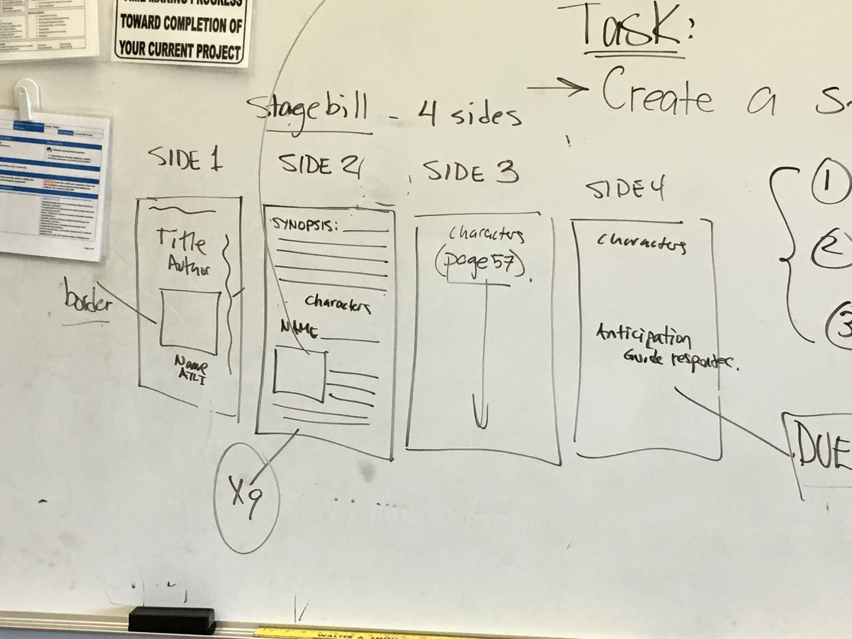
SCHEMATIC OUTLINE:

