AMERICAN SOURCES
KEY ARTWORKS FOR CURRICULUM PROJECTS
1750-1840
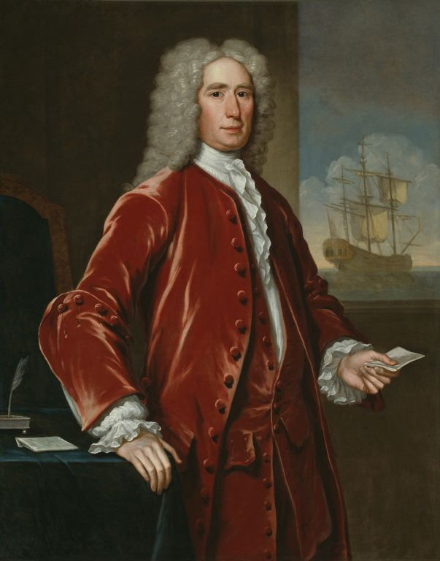 | John Smibert (American, born Scotland, 1688-1751), Richard Bill, 1733. Oil on canvas, 127.6 x 102.2 cm (50 1/4 x 48 1/4 in.). Art Institute of Chicago, 1944.28.
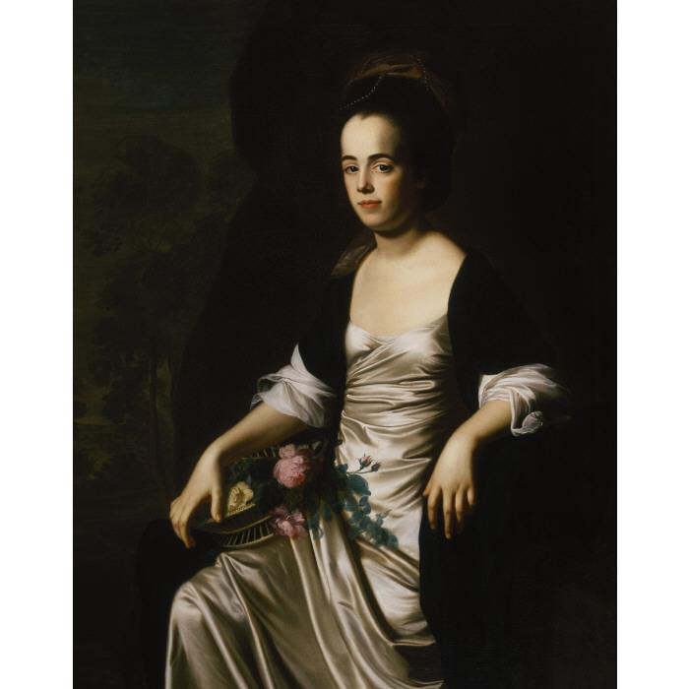 | John Singleton Copley (American, 1738-1815), Mrs. John Stevens, 1770-1772. Oil on canvas, 127.0 x 101.6 cm (50 x 40 in.). Terra Foundation for American Art, 2000.6.
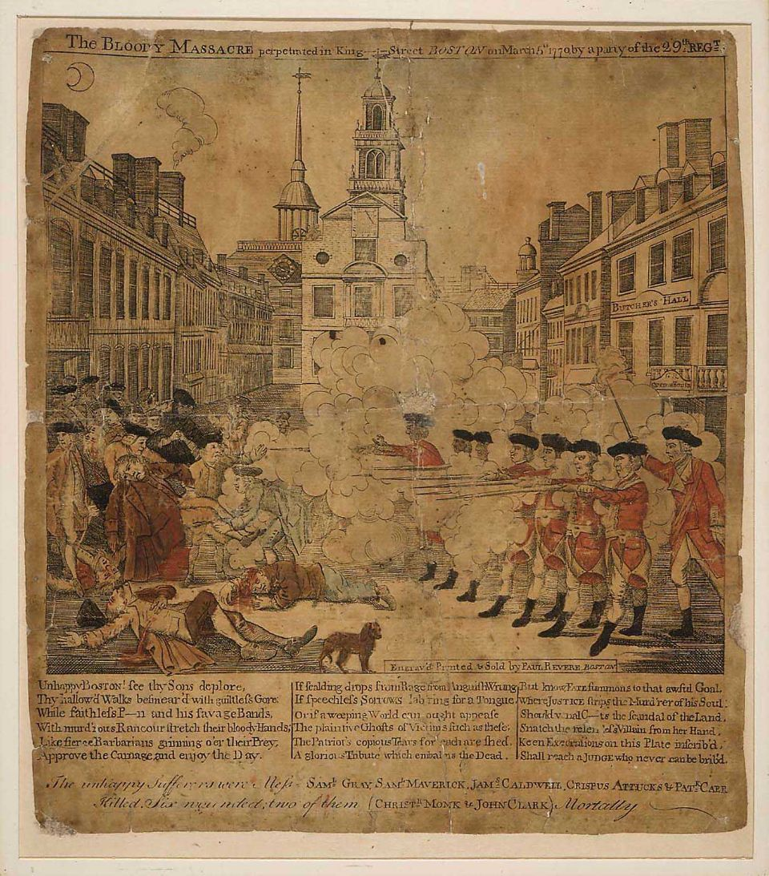 | Paul Revere, Jr. (American 1734-1818), The Bloody Massacre, 1770. Engraving, hand colored, 25.1 x 21.6 cm (9 7/8 x 8 1/2 in.). Museum of Fine Arts, Boston, 62.506.
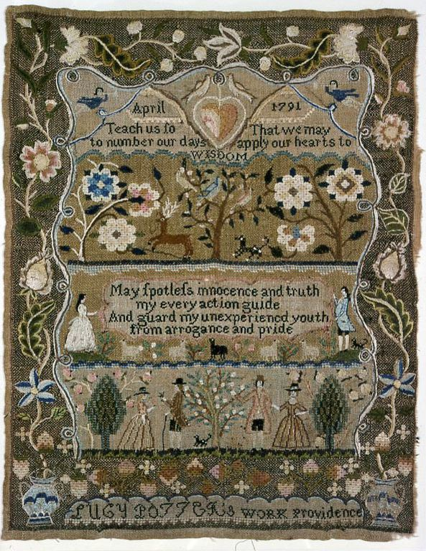 | Lucy Potter (American, active c.1791), Mary (Polly) Balch’s Academy, United States, Rhode Island, Providence, Sampler, 1791. Linen, plain weave; embroidered with silk in cross, Rococo, Roumanian, satin, stern, and tent stitches. 43.5 x 34.3 cm (17 1/8 x 13 ½ in.). Art Institute of Chicago, 1942.34
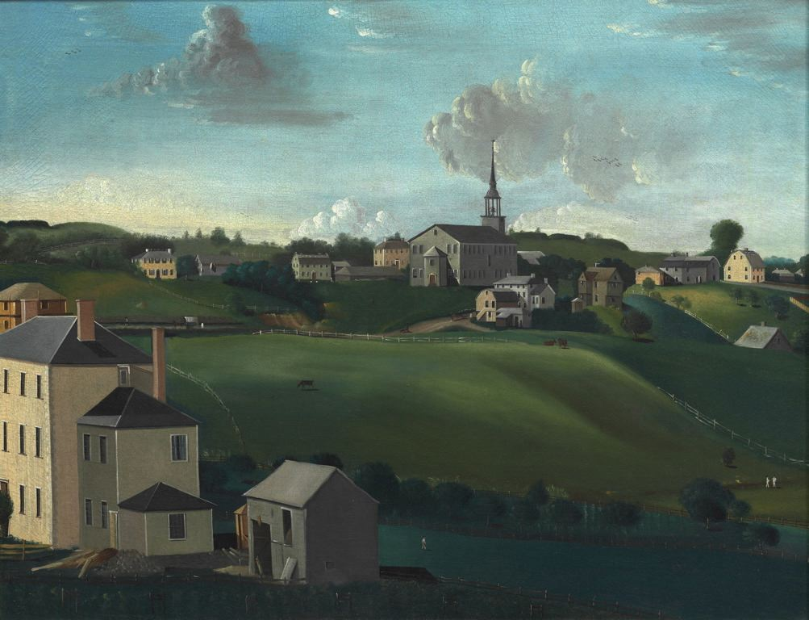 | John Ritto Penniman (American, c. 1782-1841). Meeting House, Roxbury, Massachusetts, 1799. Oil on canvas, 73.6 x 94 cm (29 x 37 in.). Art Institute of Chicago, 1979.1461.
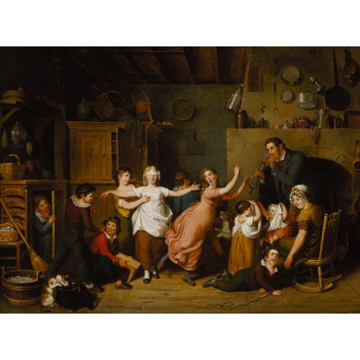 | John Lewis Krimmel (American, born Germany, 1786-1821). Blind Man’s Buff, 1814. Oil on canvas, 42.2 x 56.0 cm (16 5/8 x 22 1/16 in.). Terra Foundation for American Art, 1999.82.
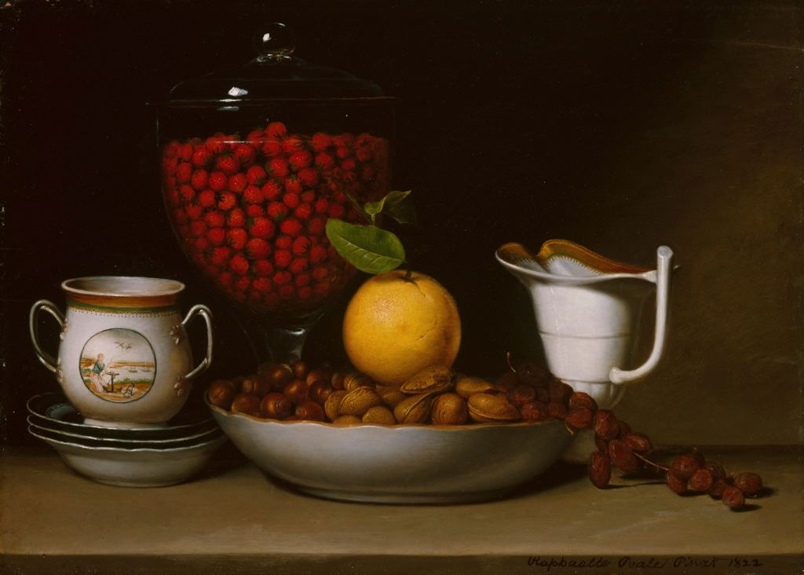 | Raphaelle Peale (American, 1774-1825), Still Life – Strawberries, Nuts, &c., 1822. Oil on wood panel, 41.1 x 57.8 cm (16 3/8 x 22 3/4 in.). Art Institute of Chicago, 1991.100.
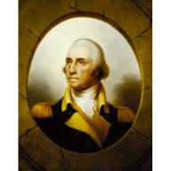 | Rembrandt Peale (American, 1778-1860), George Washington, Porthole Portrait, c. 1823. Oil on canvas, 92.1 x 74.1 cm (36 1/4 x 29 3/16 in.). Terra Foundation for American Art, 1992.53.
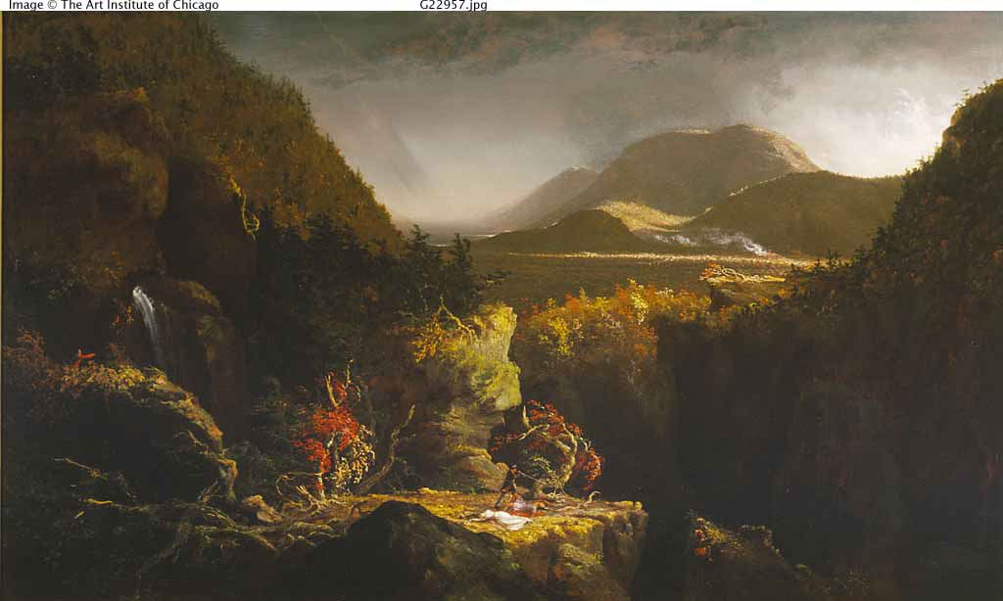 | Thomas Cole (American, 1801-1848), Landscape with Figures: A Scene from “The Last of the Mohicans”, 1826. Oil on panel, 66.4 x 109.4 cm (26 1/8 x 43 1/16 in.). Terra Foundation for American Art, 1993.2.
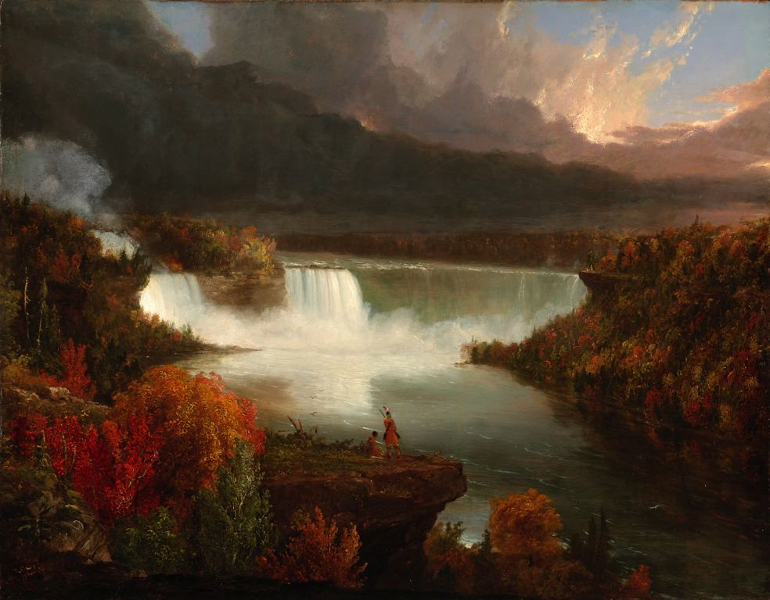 | Thomas Cole (American, 1801-1848), Distant View of Niagara Falls, 1830. Oil on panel, 47.9 x 60.6 cm (18 7/8 x 23 7/8 in.). Art Institute of Chicago, 1943.396.
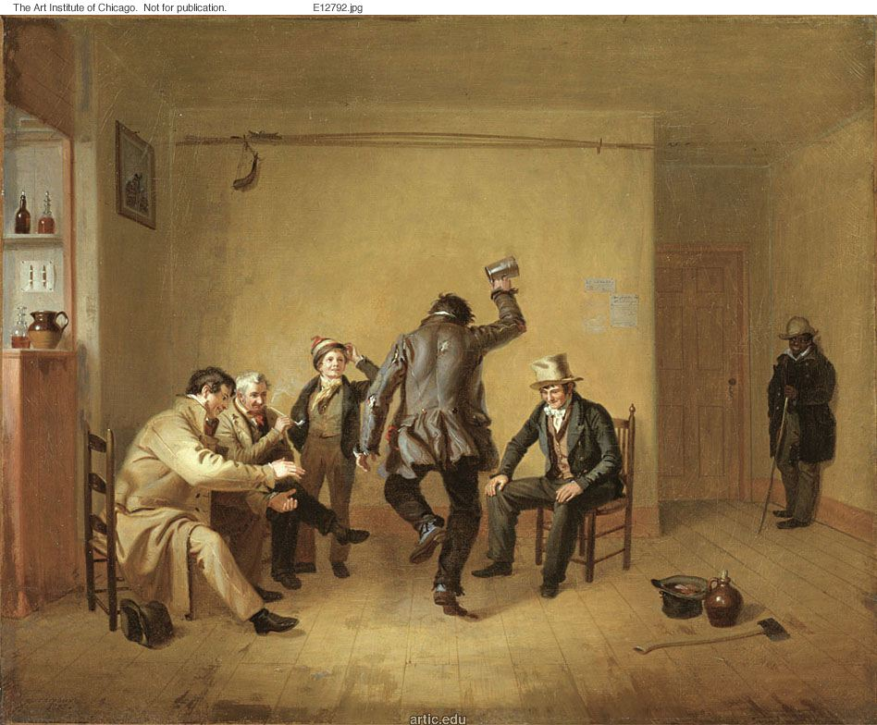 | William Sidney Mount (American, 1807-1868), Bar-room Scene, 1835. Oil on canvas, 57.4 x 69.7 cm (22 5/8 x 27 7/16 in.). Art Institute of Chicago, 1939.392.

1840-1910
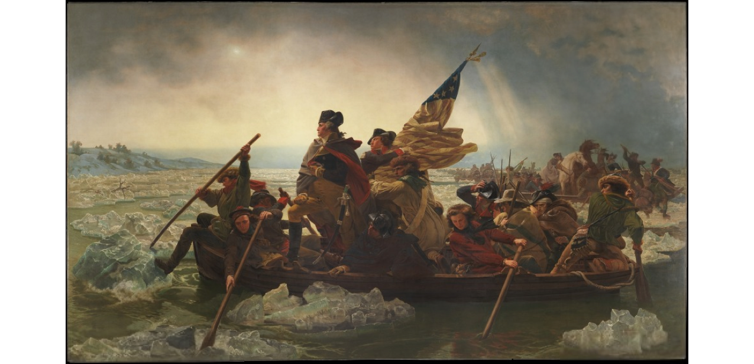 | Emanuel Leutze, (German, 1816-1868), Washington Crossing the Delaware, 1851. Oil on canvas, 378.5 x 647.7 cm (149 x 255 in.). Metropolitan Museum of Art, 1897 (97.34).
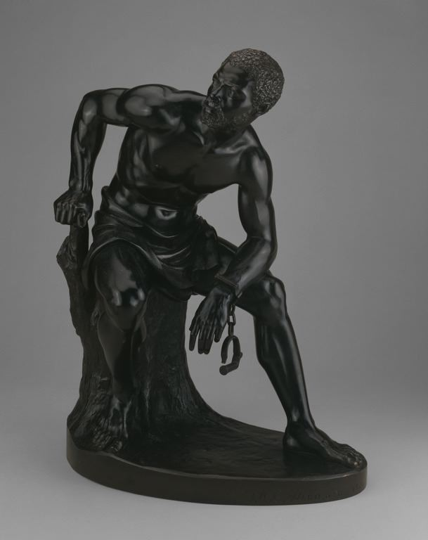 | 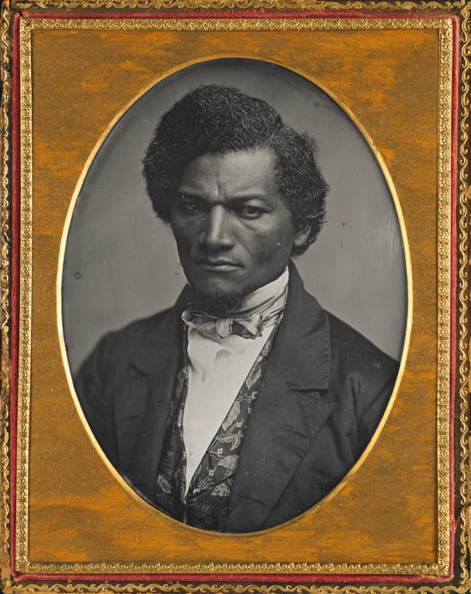  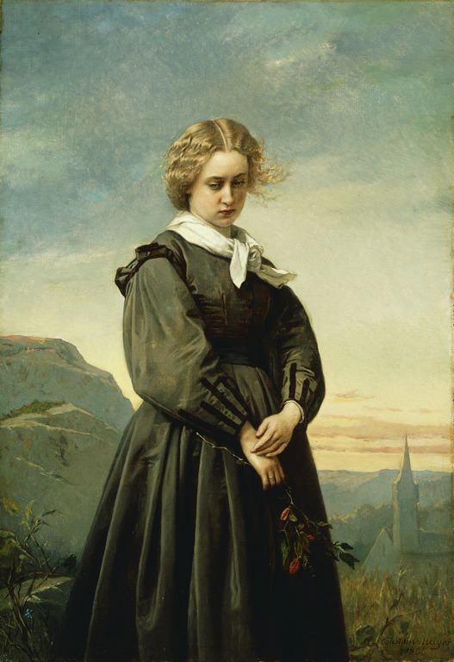  You may select these or any other artwork from the Terra or Art Institute that is included in “The Civil War in Art: Teaching and Learning through Chicago Collections.”
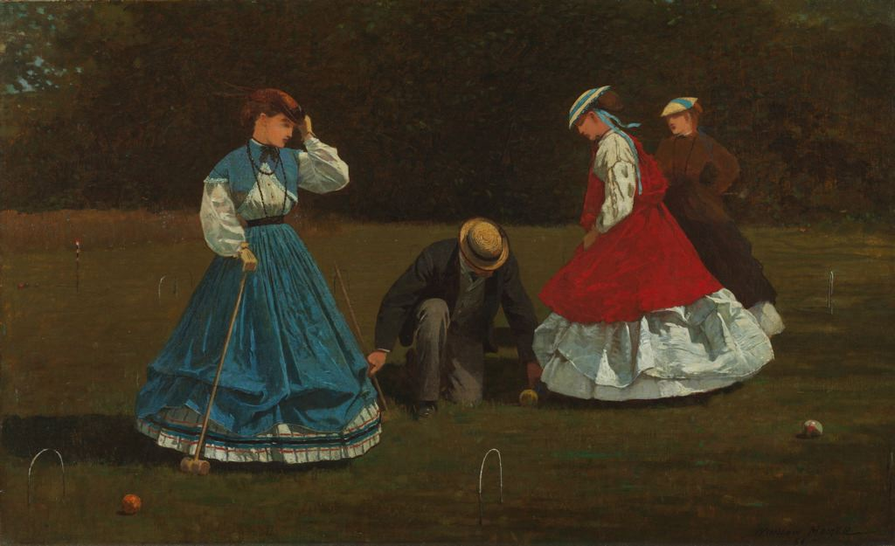 | Winslow Homer, (American, 1836-1910), Croquet Scene, 1866. Oil on canvas, 40.3 x 66.2 cm (15 7/8 x 26 1/16 in.). Art Institute of Chicago, 1942.35.
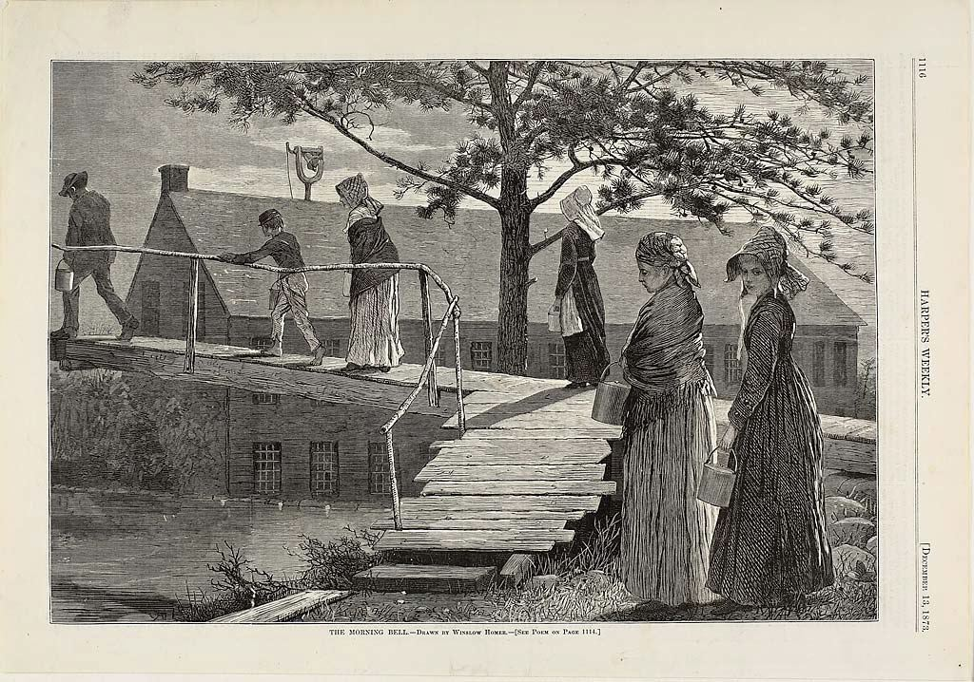 | Winslow Homer (American, 1836-1910), The Morning Bell, 1873. Wood etching on paper, 231 x 342 mm (image); 281 x 400 mm (sheet). Art Institute of Chicago, 2001.863.
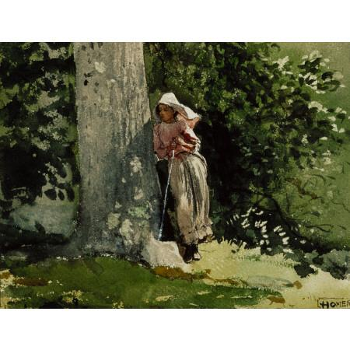 | Winslow Homer (American, 1836-1910), Weary, c. 1878. Watercolor over graphite on textured, ivory wove watercolor paper, 24.1 x 31.1 cm (9 1/2 x 12 1/4 in.). Terra Foundation for American Art, 1992.41.
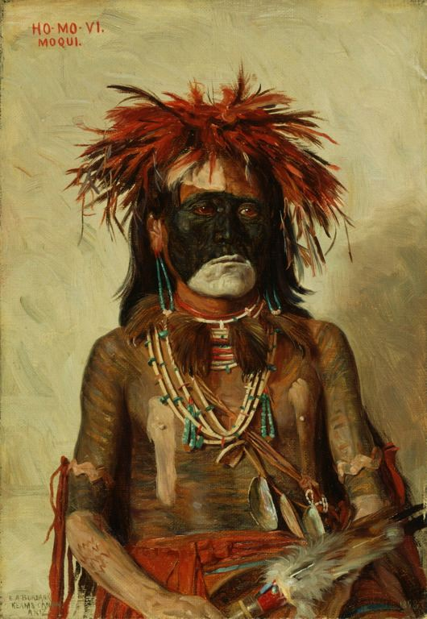 | Elbridge Ayer Burbank (American, 1858-1949), Ho-Mo-Vi/Moqui, 1898. Oil on canvas, 38.1 x 48.3 cm (15 x 19 in.). Art Institute of Chicago, 2004.8.
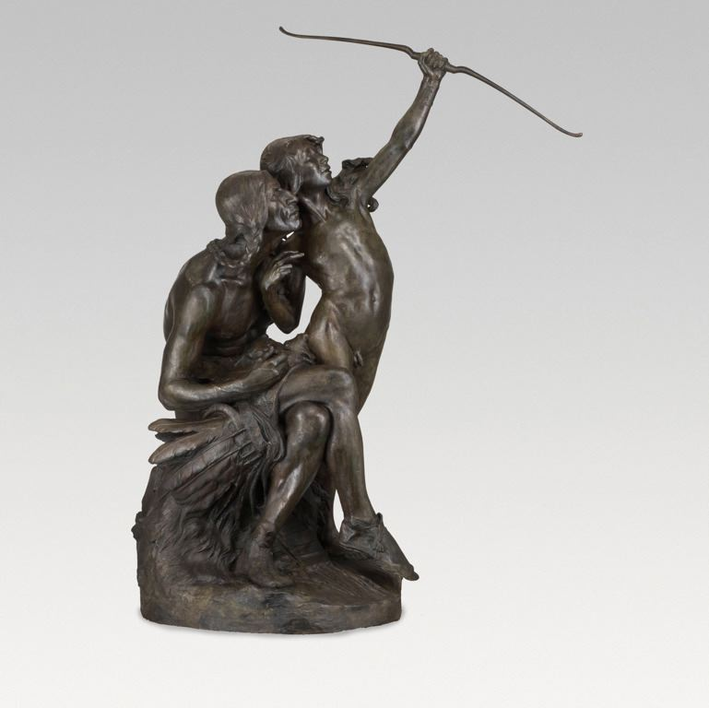 | Herman Atkins MacNeil (American, 1866-1947), The Sun Vow, modeled 1898; cast 1901. Bronze, 176.5 cm (69 1/2 in.). Art Institute of Chicago, 1926.1503.
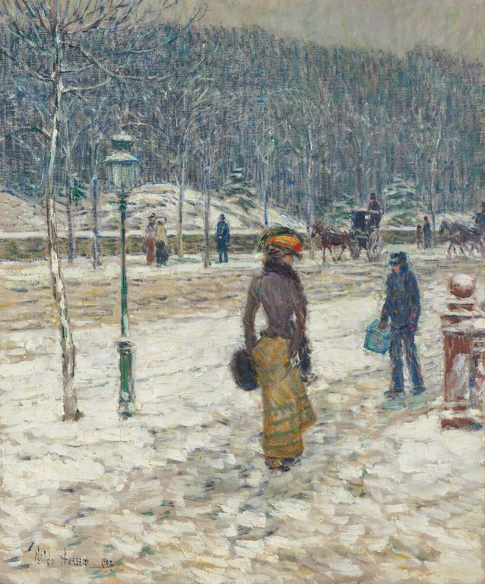 | Childe Hassam, (American, 1859-1935), New York Street, 1902. Oil on canvas, 59.7 x 49.5 cm (23 1/2 x 19 1/2 in.). Art Institute of Chicago, 1980.289.
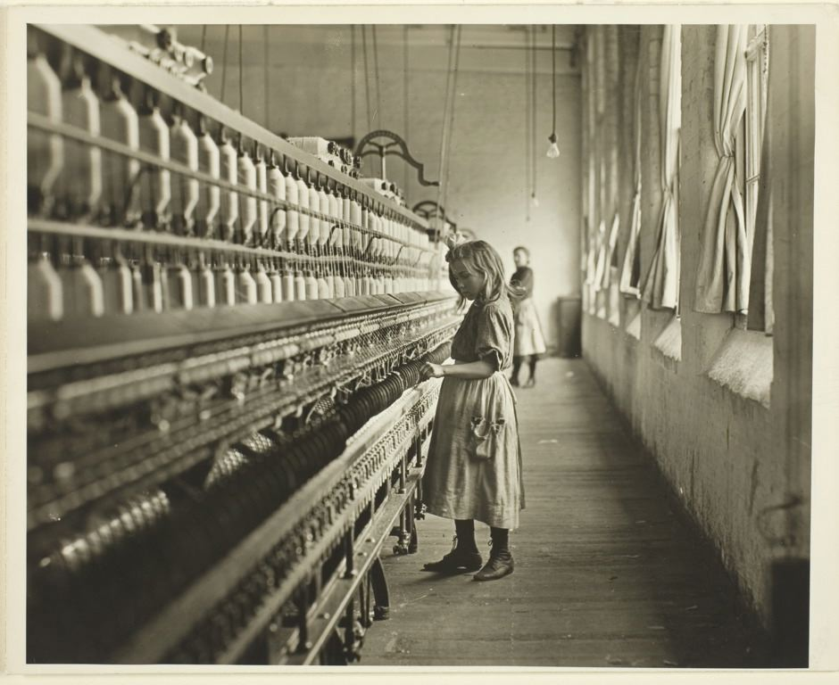 | Lewis Wickes Hine (American, 1874-1940), Sadie Pfeifer, a Cotton Mill Spinner, Lancaster, South Carolina, 1908. Gelatin silver print, 20.2 x 25.2 cm. Art Institute of Chicago, 1965.345.
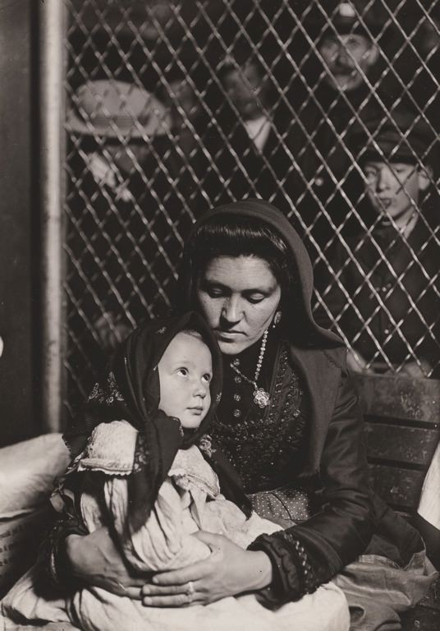 | Lewis Wickes Hine (American, 1874-1940), Immigrant Mother and Child, 1904-1909. Gelatin silver print, 17 x 12 cm. Art Institute of Chicago, 1965.323.
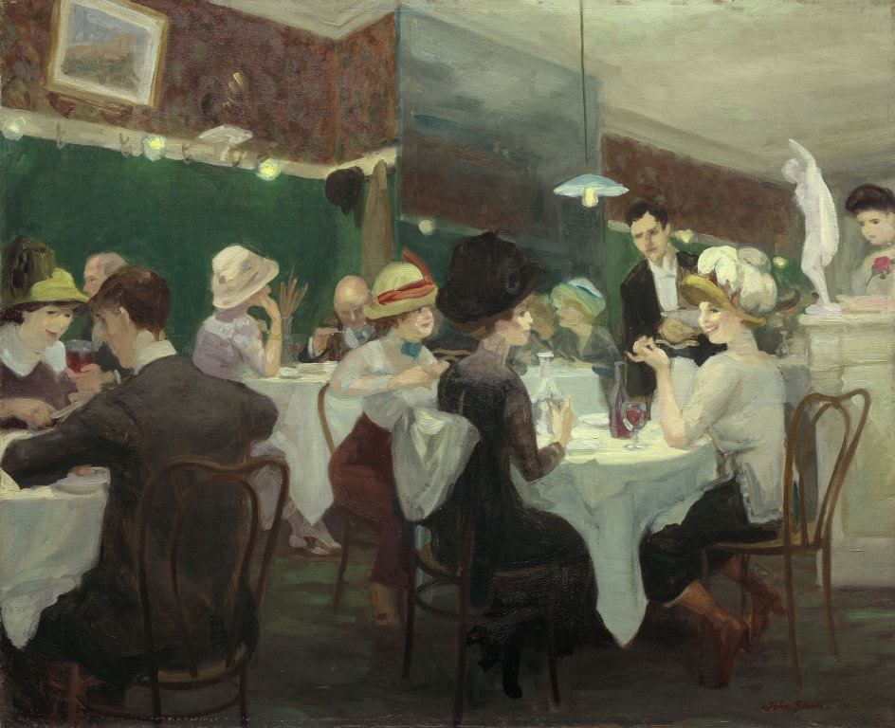 | John Sloan (American, 1871-1951), Renganeschi’s Saturday Night, 1912. Oil on canvas, 66.7 x 81.3 cm (26 1/4 x 32 in.). Art Institute of Chicago, 1926.1580.
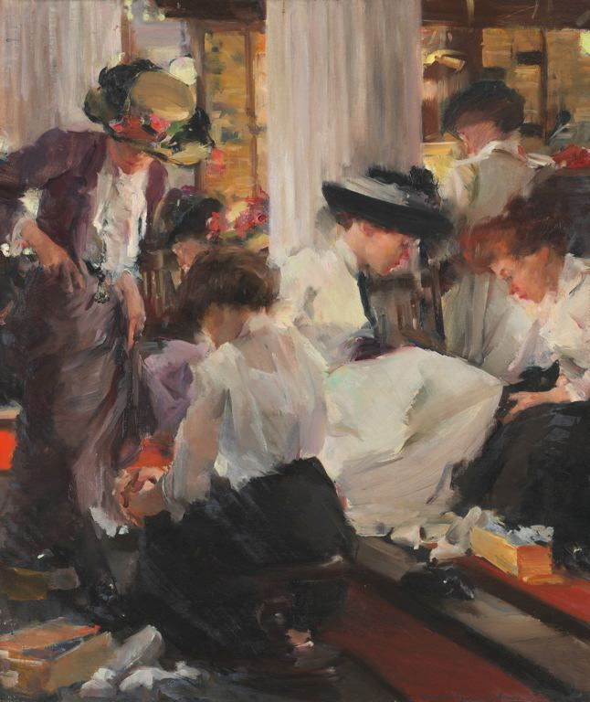 | Elizabeth Sparhawk-Jones (American, 1885-1968), Shoe Shop, c. 1911. Oil on canvas, 99.1 x 79.4 cm (39 x 33 1/4 in.). Art Institute of Chicago, 1939.393.

1910-1970
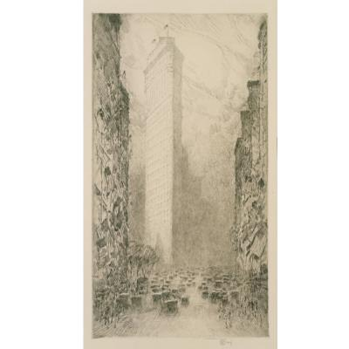 |  | Childe Hassam (American, 1859-1935), Washington’s Birthday—Fifth Avenue and 23rd Street, 1916. Drypoint and etching on cream wove paper, 32.4 x 17.8 cm (plate), 42.5 x 26.0 cm (sheet), 50.8 x 40.6 cm (mat). Terra Foundation for American Art, 1995.1.
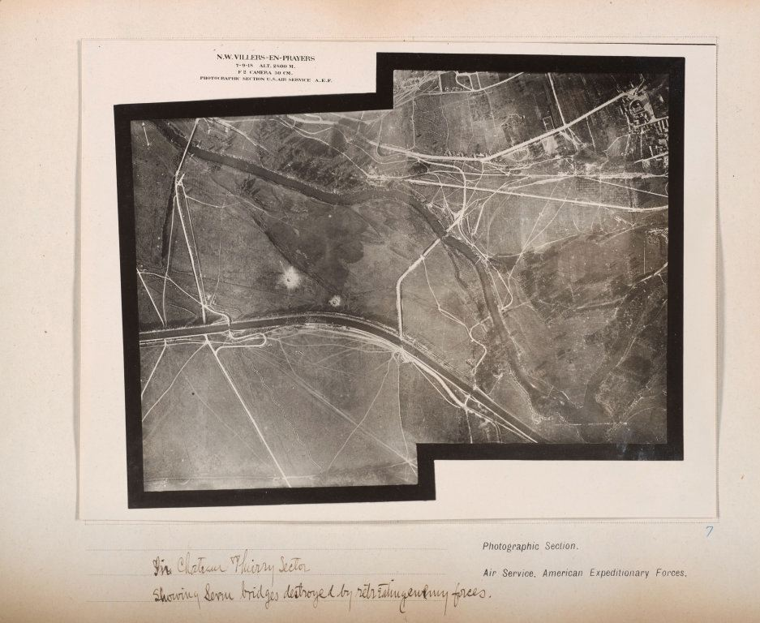 |  | Photographic Section, U.S. Air Service, American Expeditionary Forces (AEF) and Major Edward J. Steichen, A.S.A. (American, born Luxembourg, 1879-1973), In Chateau Thierry sector showing service bridges destroyed by retreating enemy forces, 1918. Gelatin silver print, from loose-leaf album of aerial photographs, 16.5 x 21 cm (image); 117.4 x 23.4 cm (paper). Art Institute of Chicago, 1977.683.
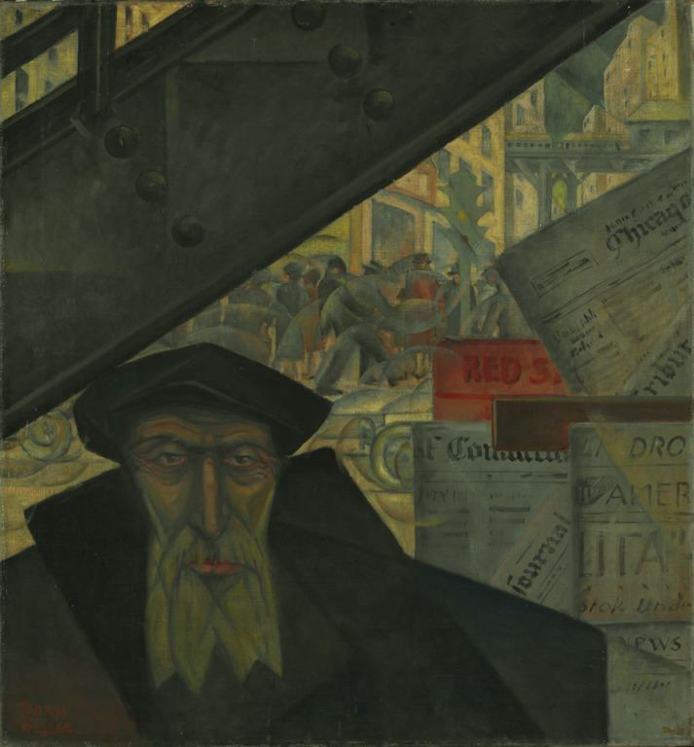 |  | Todros Geller (American, 1889-1949), Strange Worlds, 1928. Oil on canvas, 71.8 x 66.4 cm (28 ¼ x 26 1/8 in.). Art Institute of Chicago, 1949.27.
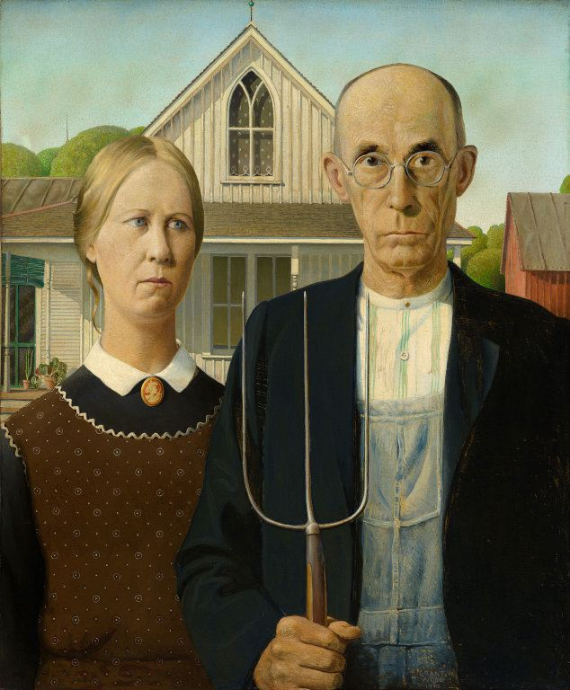 |  | Grant Wood (American, 1891-1942), American Gothic, 1930. Oil on beaver board, 78 x 65.3 cm (30 3/4 x 25 3/4 in.). Art Institute of Chicago, 1930.934.
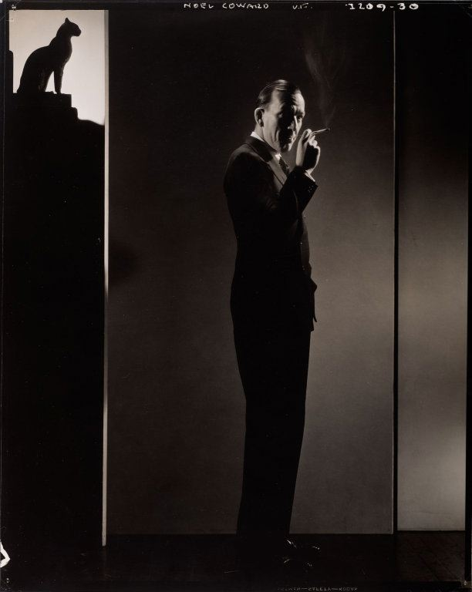 |  | Edward Steichen (American, born Luxembourg, 1879-1973), Noel Coward, 1932. Gelatin silver print, 21.9 x 19.4 cm. Art Institute of Chicago, 1982.328.
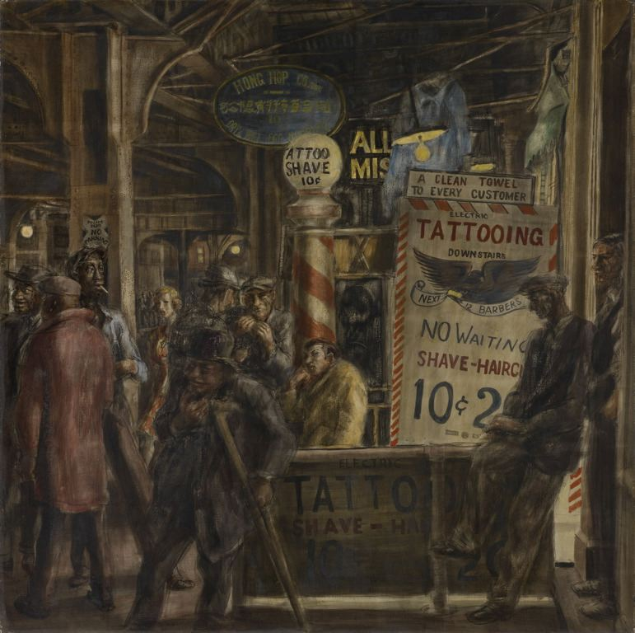 |  | Reginald Marsh (American, 1989-1954), Tattoo and Haircut, 1932. Egg tempera on masonite, 118.1 x 121.6 cm (46 1/2 x 47 7/8 in.). Art Institute of Chicago, 1947.39.
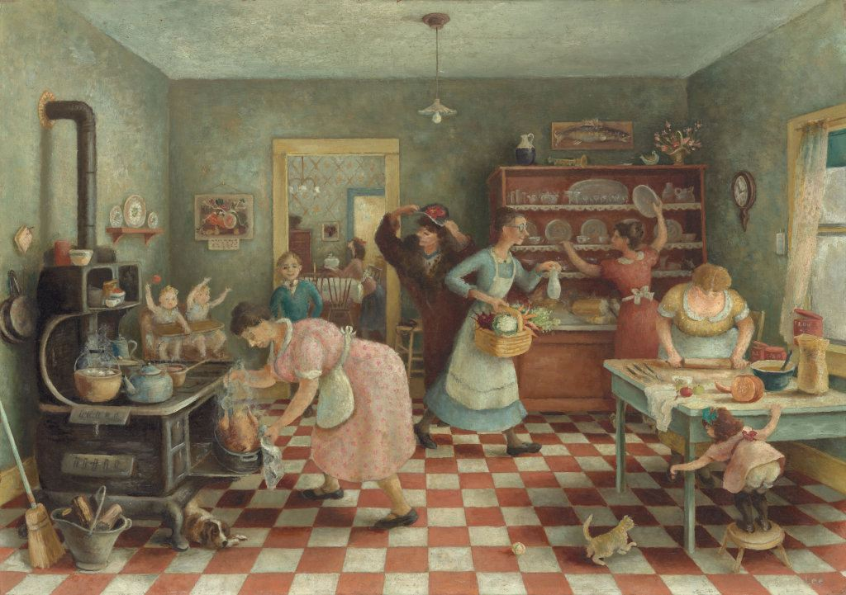 |  | Doris Lee (American, 1905-1983), Thanksgiving, c.1935. Oil on canvas, 71.3 x 101.8 cm (28 1/8 x 40 1/8 in.). Art Institute of Chicago, 1935.313.
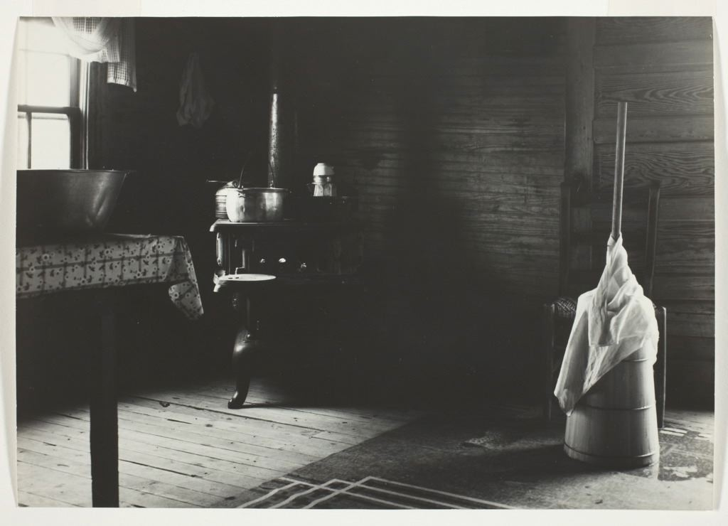 |  | Dorothea Lange (American, 1895-1965), Corner of a Kitchen of a Tobacco Sharecropper, 1935-1936. Gelatin silver print, 17 x 24 cm (6 11/16 x 9 7/16 in.). Art Institute of Chicago, 1991.1169.
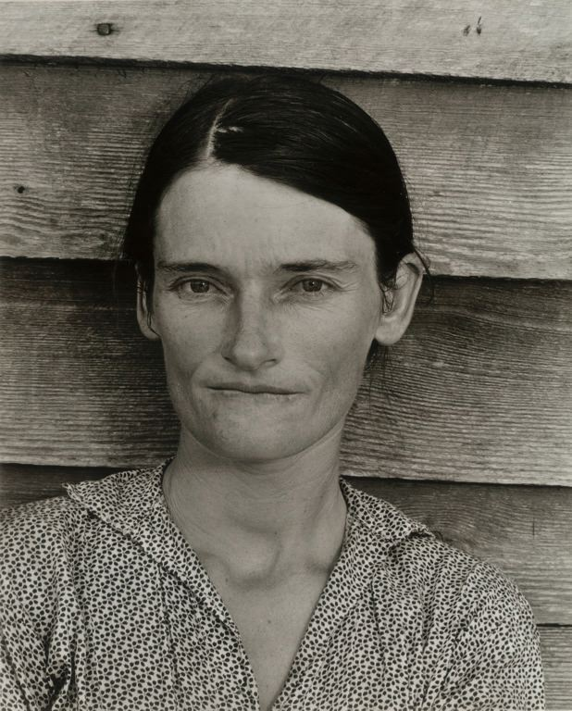 |  | Walker Evans (American, 1903-1975), Alabama Cotton Tenant Farmer’s Wife, 1936. Gelatin sliver print, 21 x 16.8 cm (8 3/16 x 6 5/8 in.). Art Institute of Chicago, 1962.158.
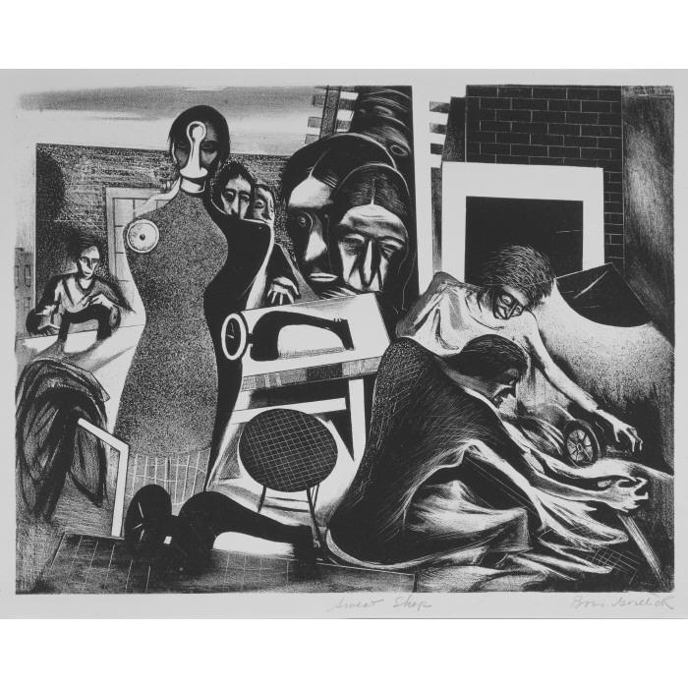 |  | Boris Gorelick (American, born Russia 1912-1984), Sweat Shop, c.1938. Lithograph on ivory wove paper, 40.6 x 58.1 cm (sheet), 50.8 x 66.0 cm (mat). Terra Foundation for American Art, 1996.70.
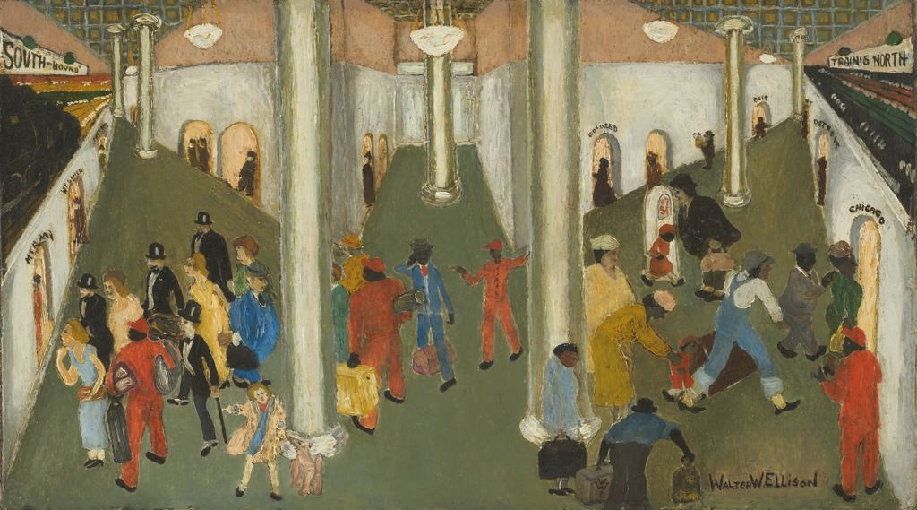 |  | Walter Ellison (American, 1899-1877), Train Station, 1935. Oil on cardboard, 20 x 36 cm (8 x 14 in.). Art Institute of Chicago, 1990.134.
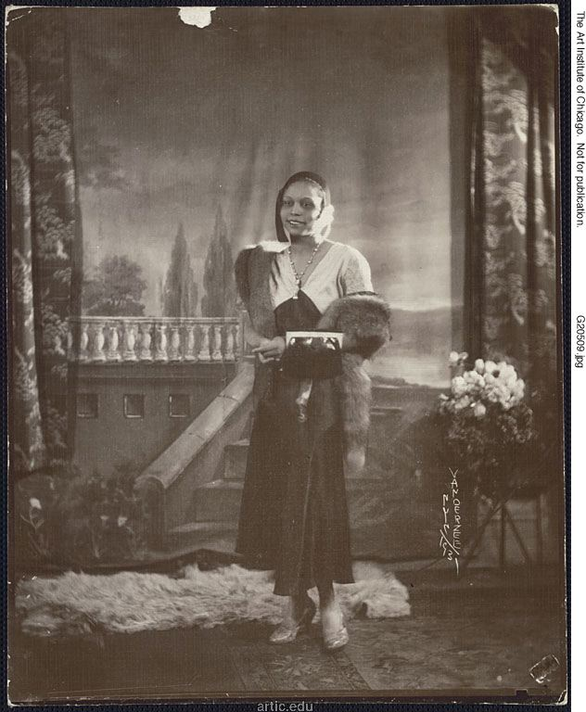 |  | James Van Der Zee (American, 1886-1983), Untitled (Young Black Woman with Studio Background), 1931. Gelatin silver print, 24.8 x 19.8 cm. Art Institute of Chicago, 2000.328
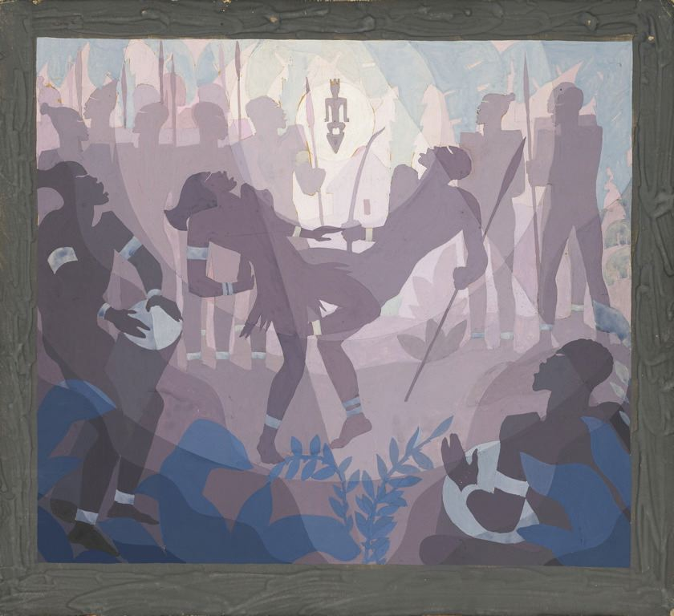 |  | Aaron Douglas (American, 1899-1979), Study for Aspects of Negro Life: The Negro in an African Setting, 1934. Gouache with touches of graphite on illustration board, 312 x 406 mm. Art Institute of Chicago, 1990.416.
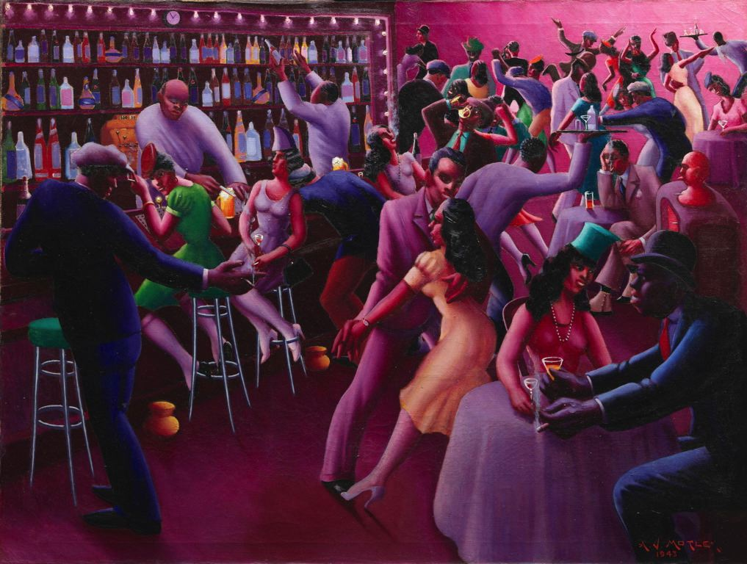 |  | Archibald J. Motley, Jr. (American, 1891-1981), Nightlife, 1943. Oil on canvas, 94.4 x 121.3 cm (36 x 47 3/4 in.). Art Institute of Chicago, 1992.89.
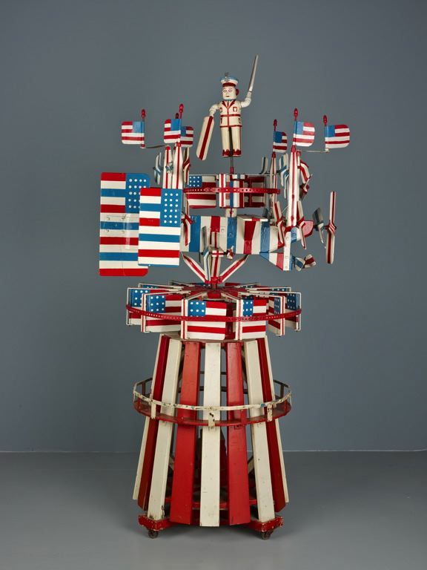 |  | Frank Memkus (American, 1884-1965), Whirligig, entitled “America,” 1938-1942. Painted wood and metal, 205.1 x 73.7 x 101.6 cm (80 3/4 x 29 x 40 in.). Art Institute of Chicago, 1980.166.
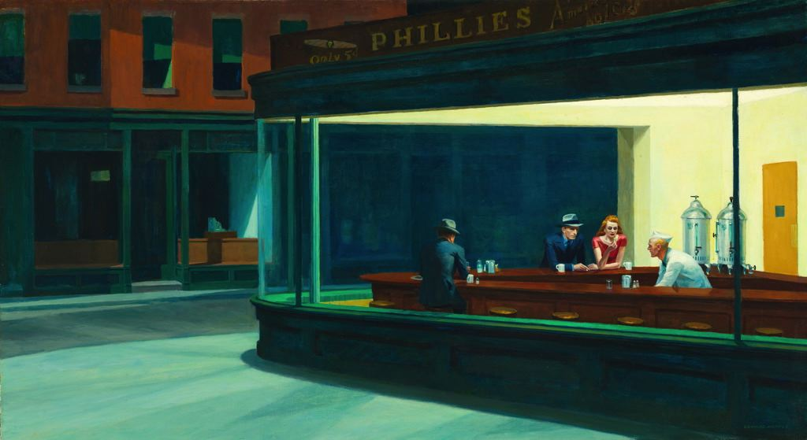 |  | Edward Hopper (American, 1882-1967), Nighthawks, 1942. Oil on canvas, 84.1 x 152.4 cm (33 1/8 x 60 in.). Art Institute of Chicago, 1942.51.
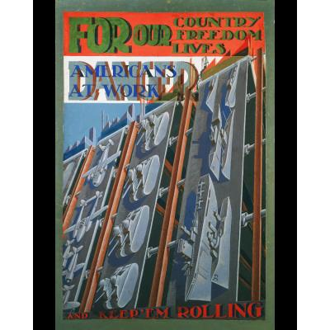 |  | Pierre Daura (American, born Spain, 1896-1976), Untitled (Americans at Work), 1942. Gouache on paper mounted to board, 47 5/8 x 28 in. (121.0 x 71.1 cm). Terra Foundation for American Art, 2000.34
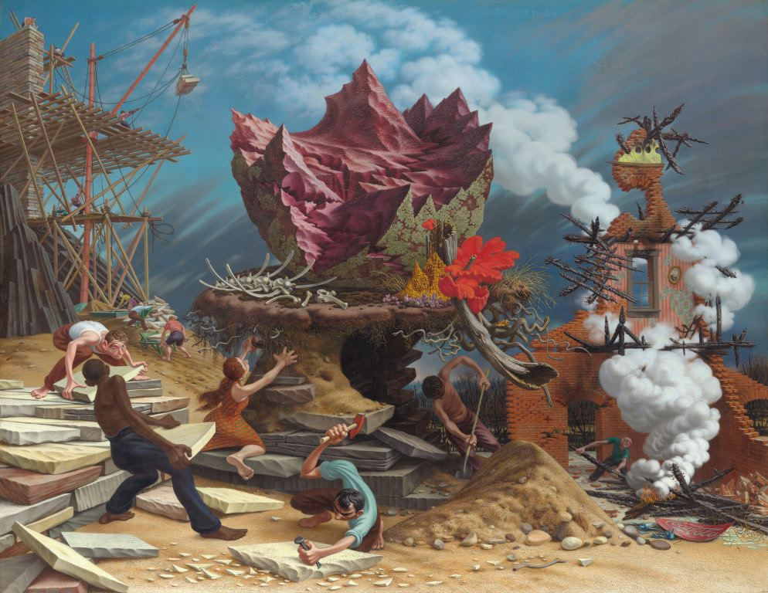 |  | Peter Blume (American, 1906-1992), The Rock, 1944-1948. Oil on canvas, 146.4 x 188.9 cm (57 5/8 x 74 3/8 in.). Art Institute of Chicago, 1956.338.
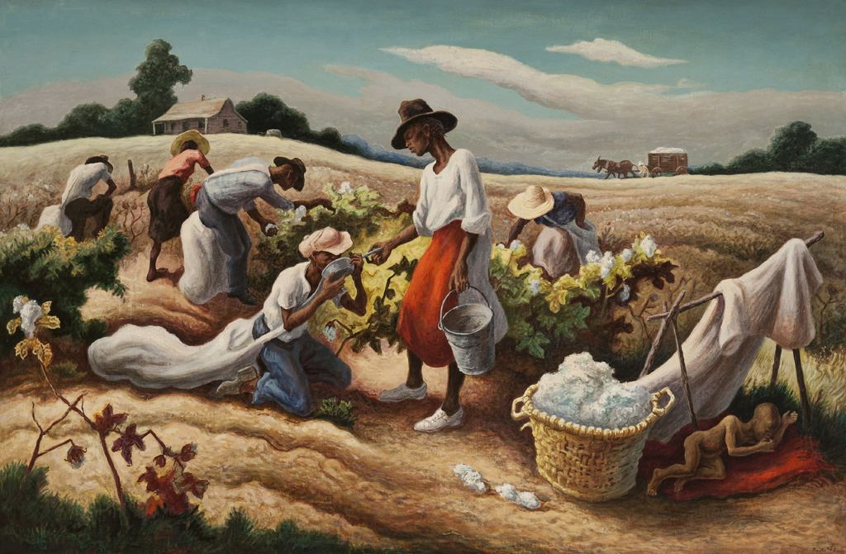 |  | Thomas Hart Benton (American, 1889-1975), Cotton Pickers, 1945. Oil on canvas, 81.3 x 121.9 cm (32 x 48 in.). Art Institute of Chicago, 2013.4.
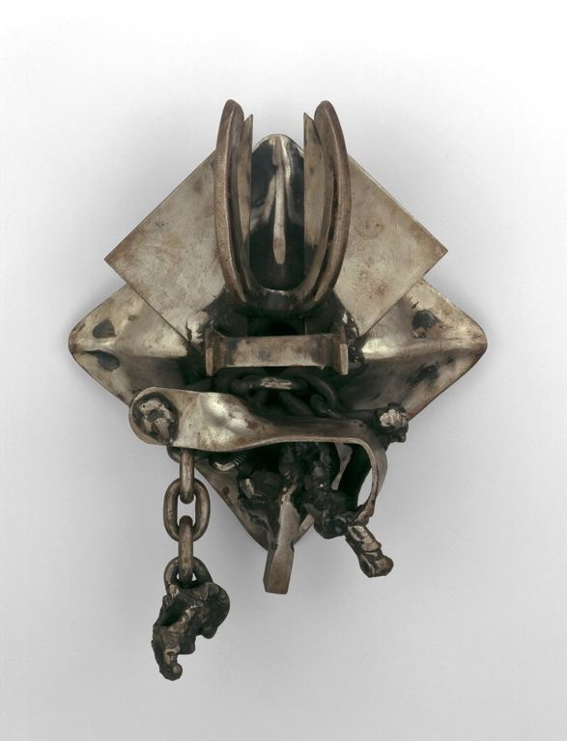 |  | Melvin Edwards (American, born 1937), Afrophoenix No. 1, 1963. Steel, 31.7 x 24.1 x 10.1 cm (12 1/2 x 9 1/2 x 4 in.). Art Institute of Chicago, 1997.411.
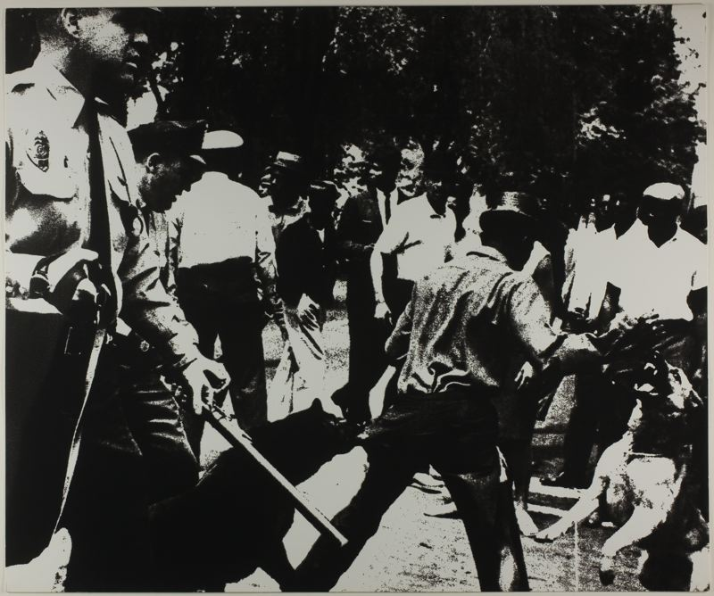 |  | Andy Warhol (American, 1928-1987); printed by Ives Silliman, Inc. (American, 20th century); published by Wadsworth Atheneum (20th-21st centuries), Birmingham Race Riot, 1964. Screenprint on white wove paper, 510 x 610 mm (image). Art Institute of Chicago, 1966.339.
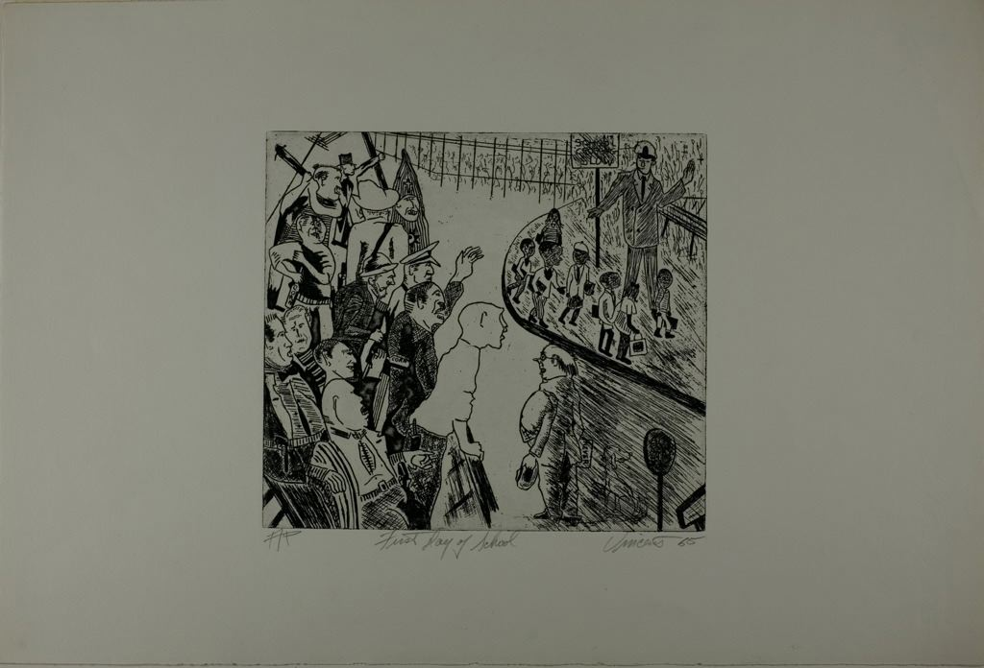 |  | Vincent Smith (American, 1929-2004), First Day of School, 1965. Etching on off-white wove paper, 227 x 252 mm (plate); 382 x 563 mm (sheet). Art Institute of Chicago, 1994.259.
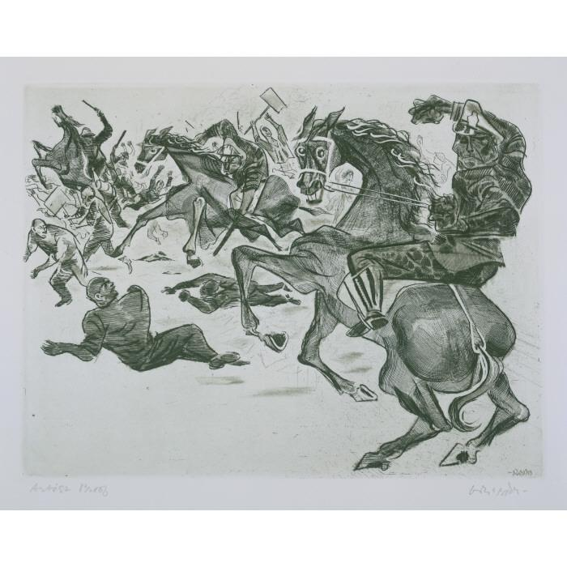 |  | William Gropper (American, 18971977), Emiliano Sorini (American, Born Italy 1897-1931), Strike Breakers, 1965. Etching on wove Rives paper, 29.8 x 39.4 cm (image), 47.3 x 55.9 cm (sheet). Terra Foundation for American Art, 2004.10.
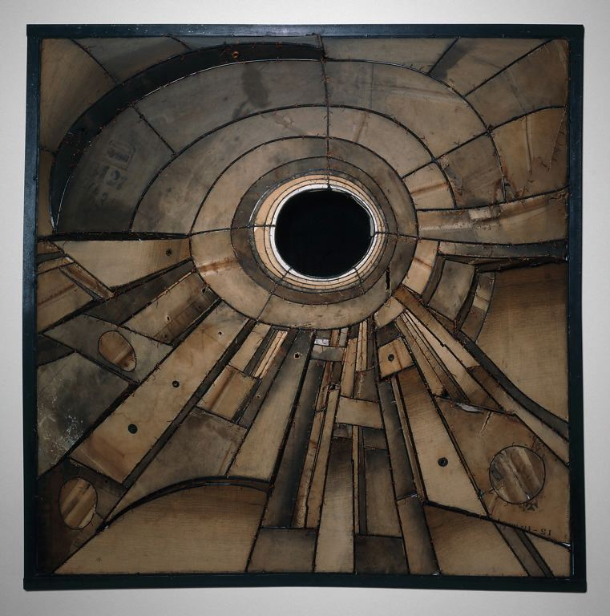 |  | Lee Bontecou (American, born 1931), Untitled, 1960. Steel, canvas, and copper wire, 182.9 x 182.9 x 45.7 cm (72 x 72 x 18 in.). Art Institute of Chicago, 1965.360.
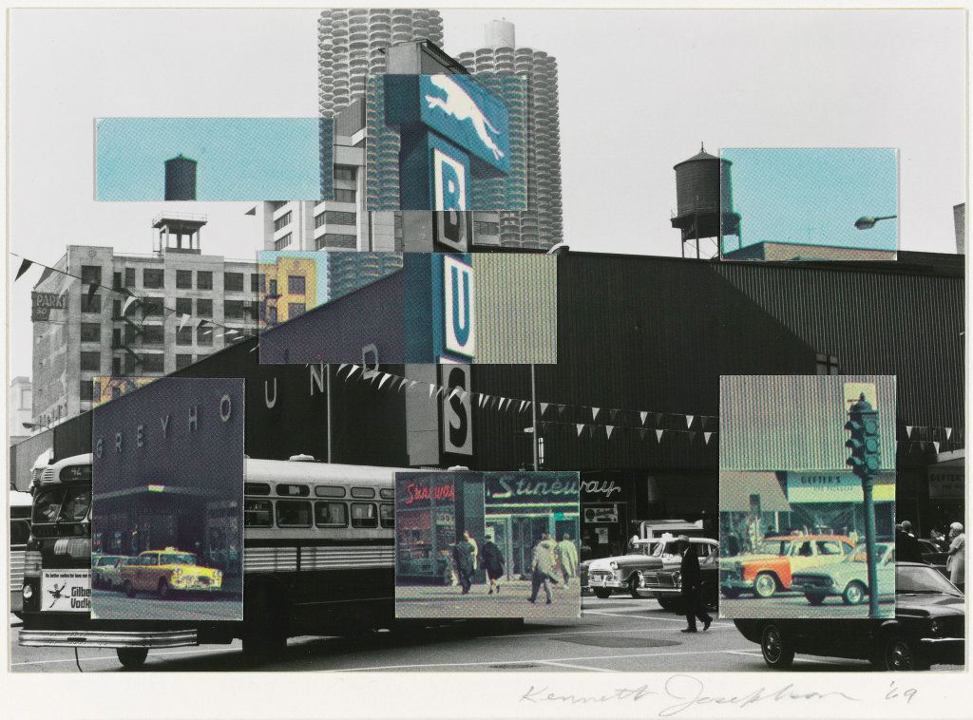 | Kenneth Josephson (American, born 1932), Chicago, 1969. Photocollage, 10.4 x 14.9 cm. Art Institute of Chicago, 1970.810.
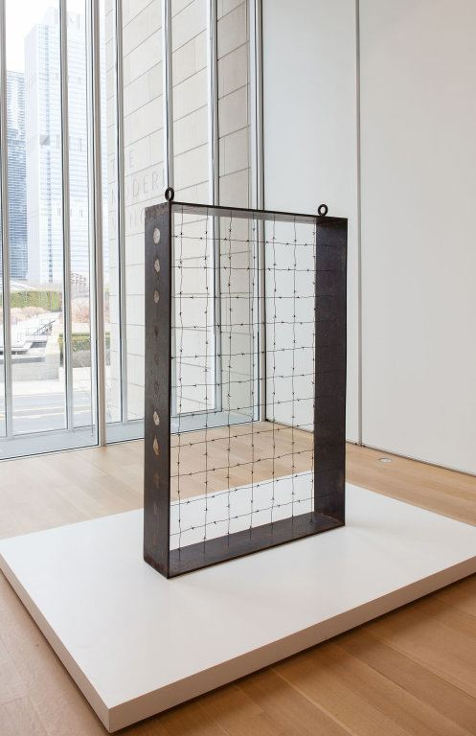 | Barnett Newman (American, 1905-1970), Lace Curtain for Mayor Daley, 1968. Cor-ten steel, galvanized barbed wire, and enamel paint, 177.8 x 121.9 x 25.4 cm (70 x 48 x 10 in.). Art Institute of Chicago, 1989.433.
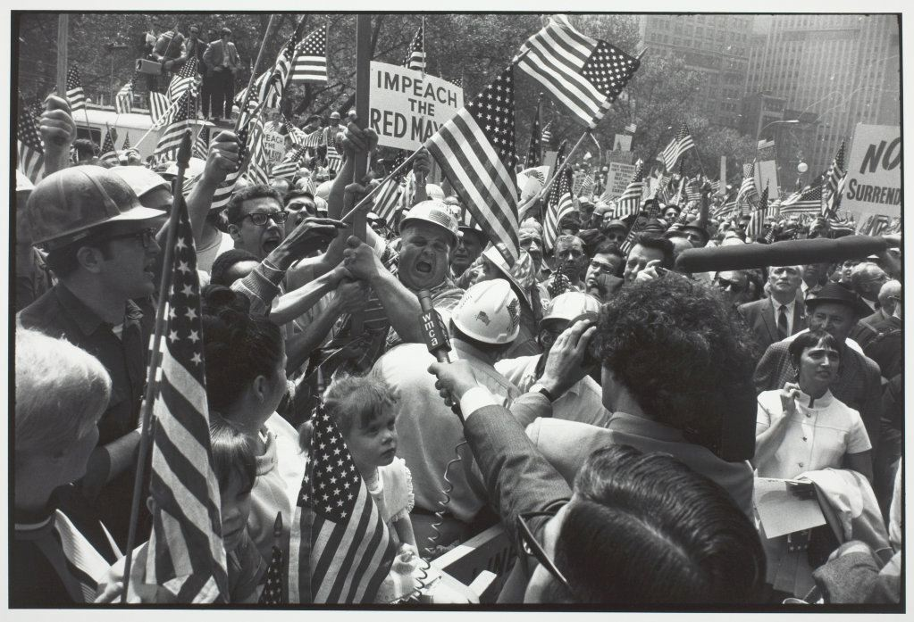 | Gary Winogrand (American, 1928-1984), Hard Hat Rally, New York, 1969. Gelatin silver print, 22.5 x 33.7 cm. Art Institute of Chicago, 1983.1520.
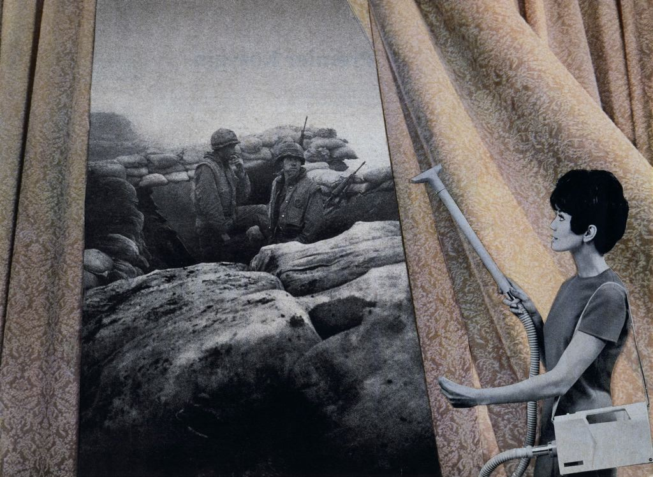 | Martha Rosler (American, born 1943), Cleaning the Drapes, from “Bringing the War Home: House Beautiful,” 1967-72. Photomontage, edition ten of ten, 50.8 x 61 cm (20 x 24 in.). Art Institute of Chicago, 2008.185.20.

