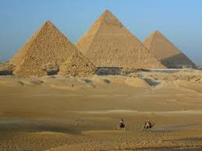
1. The pyramids at Giza, Egypt.

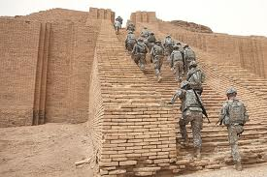
2. Mesopotamian Ziggurat.

SEARCH, PAIR, and SHARE
Directions:
Get up, leave your desk, and circulate through the room to find the other half of your image (SEARCH).

Locate your partner, introduce yourself to each other, and piece the image together (PAIR).

Discuss your understanding of the image with each other, and answer the questions below (SHARE).
- What is your image?
- Can you "connect" your image to a civilization/time-period?
- Why is it significant? What type of inferences and conclusions can you draw?

SEARCH, PAIR, and SHARE
Directions:
Get up, leave your desk, and circulate through the room to find the other half of your image (SEARCH).

Locate your partner, introduce yourself to each other, and piece the image together (PAIR).

Discuss your understanding of the image with each other, and answer the questions below (SHARE).
- What is your image?
- Can you "connect" your image to a civilization/time-period?
- Why is it significant? What type of inferences and conclusions can you draw?

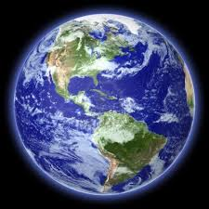
3. View of earth.

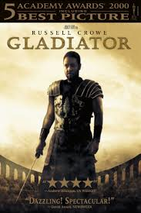
4. Roman gladiator.
SEARCH, PAIR, and SHARE
Directions:
Get up, leave your desk, and circulate through the room to find the other half of your image (SEARCH).

Locate your partner, introduce yourself to each other, and piece the image together (PAIR).

Discuss your understanding of the image with each other, and answer the questions below (SHARE).
- What is your image?
- Can you "connect" your image to a civilization/time-period?
- Why is it significant? What type of inferences and conclusions can you draw?

SEARCH, PAIR, and SHARE
Directions:
Get up, leave your desk, and circulate through the room to find the other half of your image (SEARCH).

Locate your partner, introduce yourself to each other, and piece the image together (PAIR).

Discuss your understanding of the image with each other, and answer the questions below (SHARE).
- What is your image?
- Can you "connect" your image to a civilization/time-period?
- Why is it significant? What type of inferences and conclusions can you draw?

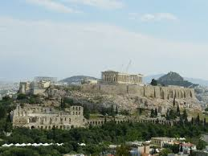
5. The Acropolis, Athens, Greece.

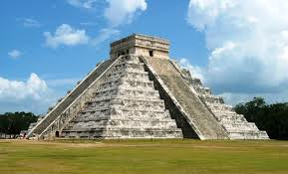
6. Aztec temple in Tenochtitlan.
SEARCH, PAIR, and SHARE
Directions:
Get up, leave your desk, and circulate through the room to find the other half of your image (SEARCH).

Locate your partner, introduce yourself to each other, and piece the image together (PAIR).

Discuss your understanding of the image with each other, and answer the questions below (SHARE).
- What is your image?
- Can you "connect" your image to a civilization/time-period?
- Why is it significant? What type of inferences and conclusions can you draw?

SEARCH, PAIR, and SHARE
Directions:
Get up, leave your desk, and circulate through the room to find the other half of your image (SEARCH).

Locate your partner, introduce yourself to each other, and piece the image together (PAIR).

Discuss your understanding of the image with each other, and answer the questions below (SHARE).
- What is your image?
- Can you "connect" your image to a civilization/time-period?
- Why is it significant? What type of inferences and conclusions can you draw?

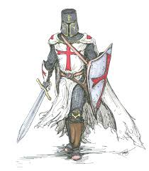
7. Medieval knight.

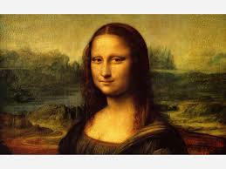
8. DaVinci's Mona Lisa
SEARCH, PAIR, and SHARE
Directions:
Get up, leave your desk, and circulate through the room to find the other half of your image (SEARCH).

Locate your partner, introduce yourself to each other, and piece the image together (PAIR).

Discuss your understanding of the image with each other, and answer the questions below (SHARE).
- What is your image?
- Can you "connect" your image to a civilization/time-period?
- Why is it significant? What type of inferences and conclusions can you draw?

SEARCH, PAIR, and SHARE
Directions:
Get up, leave your desk, and circulate through the room to find the other half of your image (SEARCH).

Locate your partner, introduce yourself to each other, and piece the image together (PAIR).

Discuss your understanding of the image with each other, and answer the questions below (SHARE).
- What is your image?
- Can you "connect" your image to a civilization/time-period?
- Why is it significant? What type of inferences and conclusions can you draw?

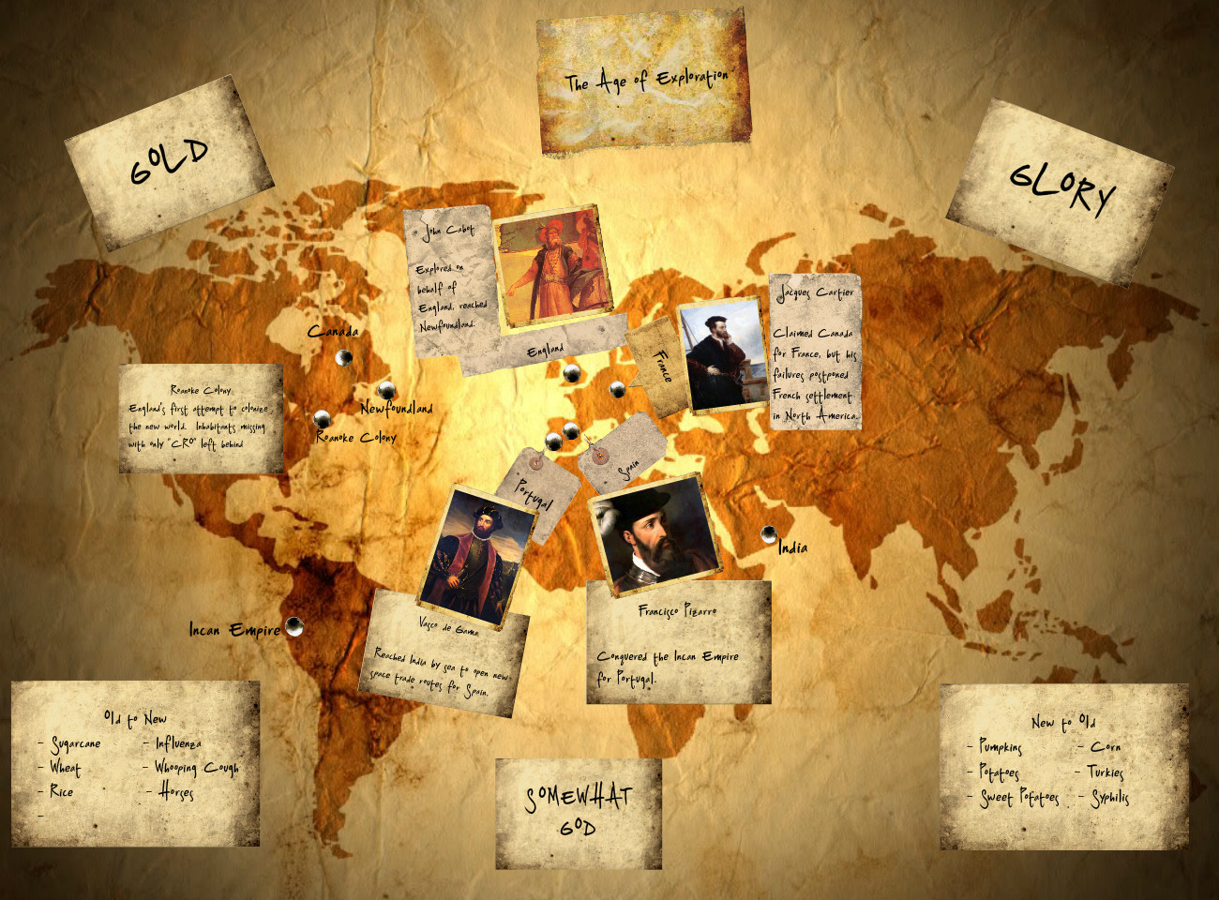
9. The Age of Exploration

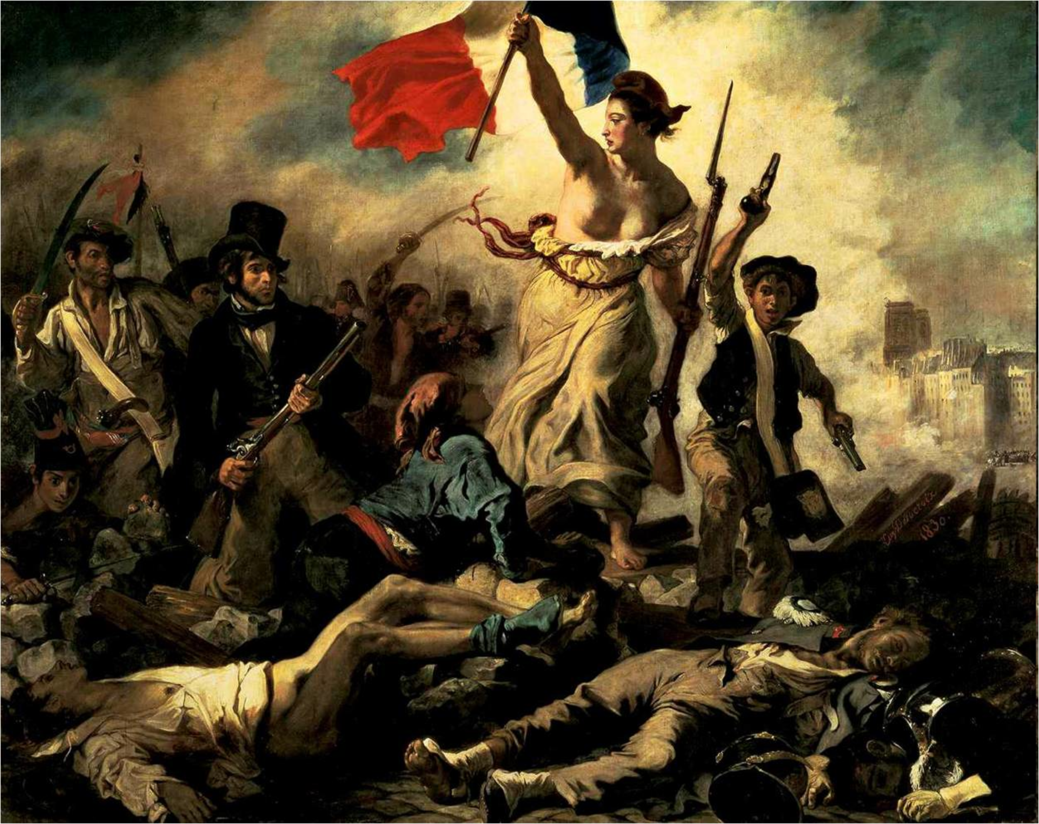
10. The French Revolution 1789 - 1795.
SEARCH, PAIR, and SHARE
Directions:
Get up, leave your desk, and circulate through the room to find the other half of your image (SEARCH).

Locate your partner, introduce yourself to each other, and piece the image together (PAIR).

Discuss your understanding of the image with each other, and answer the questions below (SHARE).
- What is your image?
- Can you "connect" your image to a civilization/time-period?
- Why is it significant? What type of inferences and conclusions can you draw?

SEARCH, PAIR, and SHARE
Directions:
Get up, leave your desk, and circulate through the room to find the other half of your image (SEARCH).

Locate your partner, introduce yourself to each other, and piece the image together (PAIR).

Discuss your understanding of the image with each other, and answer the questions below (SHARE).
- What is your image?
- Can you "connect" your image to a civilization/time-period?
- Why is it significant? What type of inferences and conclusions can you draw?

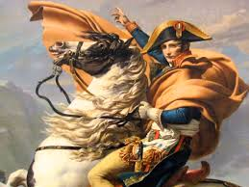
11. Napoleon's rise and fall from POWER.

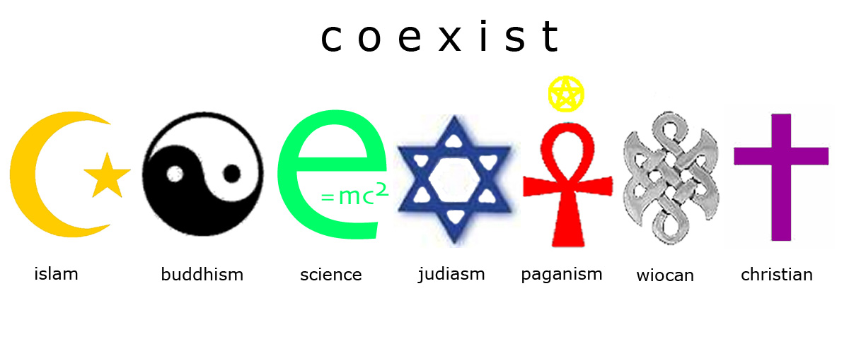
12. Religion.
SEARCH, PAIR, and SHARE
Directions:
Get up, leave your desk, and circulate through the room to find the other half of your image (SEARCH).

Locate your partner, introduce yourself to each other, and piece the image together (PAIR).

Discuss your understanding of the image with each other, and answer the questions below (SHARE).
- What is your image?
- Can you "connect" your image to a civilization/time-period?
- Why is it significant? What type of inferences and conclusions can you draw?

SEARCH, PAIR, and SHARE
Directions:
Get up, leave your desk, and circulate through the room to find the other half of your image (SEARCH).

Locate your partner, introduce yourself to each other, and piece the image together (PAIR).

Discuss your understanding of the image with each other, and answer the questions below (SHARE).
- What is your image?
- Can you "connect" your image to a civilization/time-period?
- Why is it significant? What type of inferences and conclusions can you draw?

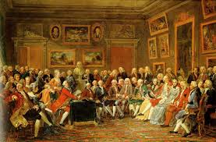
13. "Salons" of the Enlightenment.

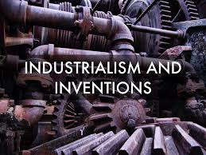
14. The Age of Industry.

SEARCH, PAIR, and SHARE
Directions:
Get up, leave your desk, and circulate through the room to find the other half of your image (SEARCH).

Locate your partner, introduce yourself to each other, and piece the image together (PAIR).

Discuss your understanding of the image with each other, and answer the questions below (SHARE).
- What is your image?
- Can you "connect" your image to a civilization/time-period?
- Why is it significant? What type of inferences and conclusions can you draw?

SEARCH, PAIR, and SHARE
Directions:
Get up, leave your desk, and circulate through the room to find the other half of your image (SEARCH).

Locate your partner, introduce yourself to each other, and piece the image together (PAIR).

Discuss your understanding of the image with each other, and answer the questions below (SHARE).
- What is your image?
- Can you "connect" your image to a civilization/time-period?
- Why is it significant? What type of inferences and conclusions can you draw?

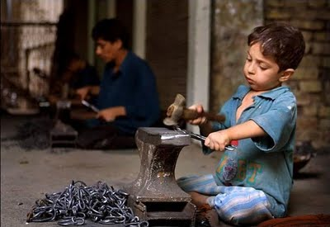
15. Child labor.

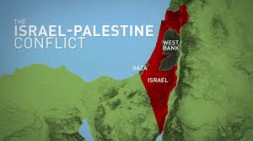
16. Conflict
SEARCH, PAIR, and SHARE
Directions:
Get up, leave your desk, and circulate through the room to find the other half of your image (SEARCH).

Locate your partner, introduce yourself to each other, and piece the image together (PAIR).

Discuss your understanding of the image with each other, and answer the questions below (SHARE).
- What is your image?
- Can you "connect" your image to a civilization/time-period?
- Why is it significant? What type of inferences and conclusions can you draw?

SEARCH, PAIR, and SHARE
Directions:
Get up, leave your desk, and circulate through the room to find the other half of your image (SEARCH).

Locate your partner, introduce yourself to each other, and piece the image together (PAIR).

Discuss your understanding of the image with each other, and answer the questions below (SHARE).
- What is your image?
- Can you "connect" your image to a civilization/time-period?
- Why is it significant? What type of inferences and conclusions can you draw?

