Scavenger Hunt – Know Your Peers Activity

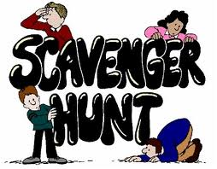
Get ready for the hunt. Use the assigned time to circulate around the class and get better acquainted with your classmates. You will have 20 minutes to complete. Use your "soft" voices while "hunting." Find a classmate (first and last name) that has done the following, and record their name/answer. You cannot use a name more than 3 times. We will share our findings at the end of class, and you will submit for a grade. Good Luck!

Find someone who … | Name/response
1. Traveled to another state or country.
2. Went camping, hiking or rafting.
3. Went to a Cub's or Sox's game.
4. Read a book that they would recommend to others. Name the title and/or author.
5. Sang or danced at a concert or a gathering.
6. Attended or planned a family reunion.
7. Enjoyed something new in Chicago.
8. Went to a museum or cultural institution in Chicago.
9. Worked at a summer job.
10. Saw a movie he/she would see again.
11. Went to an exciting concert or event.
12. Tried a new recipe they would be willing to share.
13. Tried something new or different.
14. Went to a wedding or other celebration.
15. Knows the capital city of Austria.
16. Enjoys helping others.
17. Loves chocolate.
18. Sends 20 text messages on their phone daily. (No phones in school please)
19. Owns a pet. What kind?
20. Dislikes scavenger hunts.

