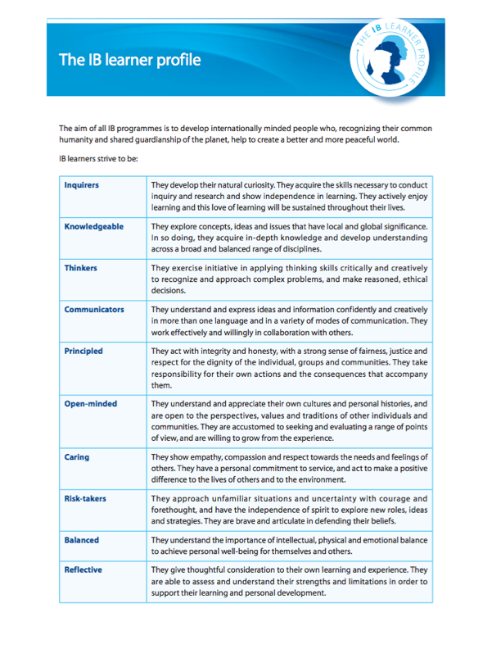STUDENT TASK: Create a concept map in which you select one (1) trait that you believe you embody, and one (1) trait you would like to “improve” upon. For each trait you would have to include the following: Trait name, description in your own words, an image that supports the trait, and your connection to the trait. Create draft on the reverse side, and then produce a final copy.

Trait Name
Explanation in own words
Image (draw or cut out)
Connection to trait (personal or example)

Trait Name
Explanation in own words
Image (draw or cut out)
Connection to trait (personal or example)

