- HOME PAGE
- About me
- About Program
- Favorite Video (with comment and description)
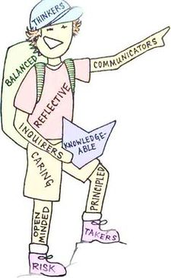
- IB Profile Traits
- ATL SKILLS
- Pic with overview
- Personal Development with pic
- Communication with pic
- Thinking with pic
- Intercultural understanding with pic
- REFLECTIVE PROJECT
- Overview with pic
- Student guide file
- RP rubric file
- RP description
- Uploaded videos/ppt (file)
- Uploaded essay (file)
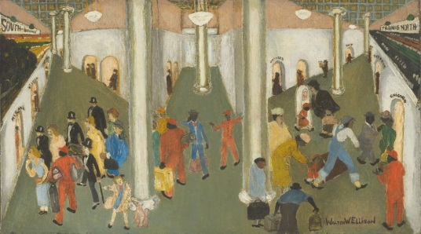
- AMERICAN SOURCES
- Program Description w/ pic
- Ellison’s Train Station
i. Description and PowerPoint
- Your Artwork
- Description and PowerPoint
- LANGUAGE B DEVELOPMENT
- Introduction
- Language Description
i. Why Language got picked
- Evidence
- Self-assessment (before & after)
- COMMUNITY SERVICE
- Picture and Description
- Written of every Service Reflective (of 40 hours or more)
- BLOG
- Videos (6) w/ description
- Education, Inspiration, Human Nature, Values, Ethics & Philosophy, Personal

