IBCP PROGRAM

Personal and Professional Skills (PPS I)

2019-20 / ROOM 247

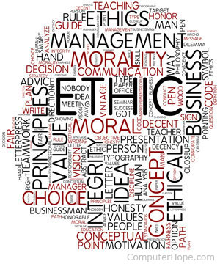

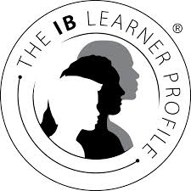

What is PPS?

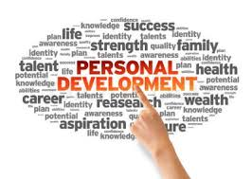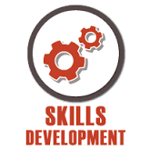

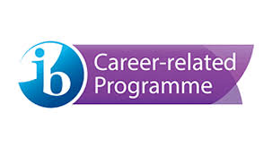

NAME:____________________________________________________________________________ PERIOD:_________